**Data Security and Privacy in Big Data Analysis Using IBM Cloud Databases**

|  |  |
| --- | --- |
| **Date** | **25-10-2023** |
| **Team ID** | **4190** |
| **Project Name** | **Data Security and Privacy in Big Data Analysis Using IBM Cloud Databases** |

**Table of Contents**

|  |  |
| --- | --- |
| 1. | Introduction |
| 2. | Problem Statement |
| 3. | IBM Cloud Account Creation |
| 4. | Database Setup |
| 4.1 | Choosing Database Services |
| 4.2 | Setting up a Database Instance |
| 5. | Data Exploration and Analysis |
| 5.1 | Query to explore the dataset |
| 6. | Data cleaning and Transformation |
| 7. | Conclusion |

**1. Introduction**

In the era of data abundance, organizations are accumulating massive datasets across diverse domains, presenting both opportunities and challenges. IBM Cloud Databases offer a robust platform for Big Data analysis, promising the discovery of valuable insights and data-driven adventures. and this project aims to utilize innovative approaches to enhance prediction accuracy and reliability on data security and privacy in Big Data analysis.

**2. Problem Statement**

The project involves delving into big data analysis using IBM Cloud Databases. The primary objective of the project is to implement robust data security and privacy measures in the context of big data analysis using IBM Cloud datasets. This involves safeguarding sensitive information from potential threats, ensuring compliance with relevant regulations, and enabling secure and ethical use of data for analytics purposes .The project includes designing the analysis process, setting up IBM Cloud Databases, performing data analysis, and visualizing the results for business intelligence.

**3. IBM Cloud Account Creation:**

Created an IBM Cloud account, which now provides access to various cloud services and resources.

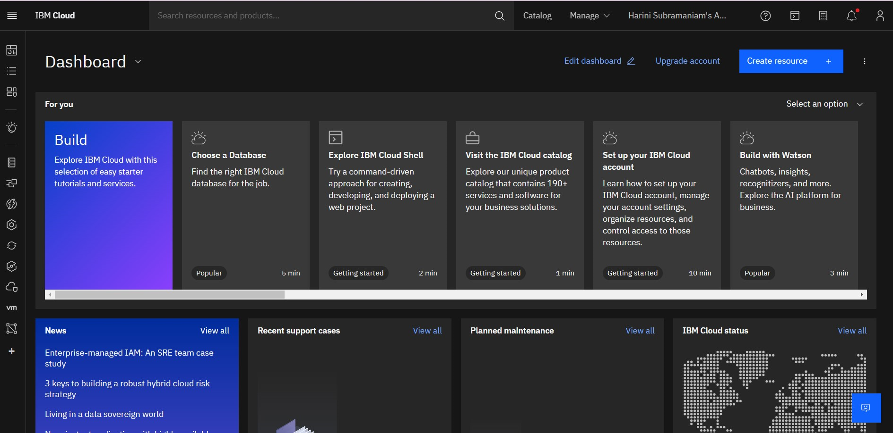

The IBM Cloud account will be utilized for accessing various instances (e.g.,Db2 instance, MongoDB).

**4. Database Setup:**

**4.1 Choosing Database Services**

cloud database services for data security and privacy in big data analysis using IBM Cloud datasets, several services offer features that are crucial for meeting security and privacy requirements. Here are some of the key IBM Cloud database services to consider, along with their features.

**IBM Db2 on Cloud:**

**Key Features:**

Enterprise-grade relational database management system, Supports structured data, Robust security features, including encryption at rest and in transit.

Role-based access controls (RBAC) for user management and Compliance with industry regulations (HIPAA, GDPR).

**IBM Cloudant:**

**Key Features:**

NoSQL database for non-relational data (JSON documents),Scalable and distributed architecture, Built-in security features, including role-based access controls.

Supports encryption in transit and at rest and Geographically distributed clusters for high availability.

**IBM Db2 Warehouse on Cloud:**

**Key Features:**

Data warehousing solution optimized for analytics, It supports both structured and unstructured data, Advanced analytics and machine learning capabilities.

Security features include encryption and access controls and Scalable for large-scale data analysis.

**IBM Cloud SQL Query:**

**Key Features:**

Serverless SQL service for analyzing large datasets stored in Cloud Object Storage, Supports ad-hoc SQL queries for data analysis.

Enables secure and efficient data analysis directly on data in Cloud Object Storage and access controls and encryption for data security.

**IBM Compose for PostgreSQL:**

**Key Features:**

Managed PostgreSQL service for relational data and Automatic backups and point-in-time recovery for data protection.

Supports encryption at rest, scalable and flexible for various workloads and provides a role-based access controls for security.

**IBM Cloud Object Storage:**

**Key Features:**

Object storage service for scalable and durable storage of unstructured data, Encryption at rest with server-side encryption with Fine-grained access controls and bucket policies.

Integration with other IBM Cloud services and Ideal for storing large volumes of data for big data analytics.

**IBM Watson Studio:**

**Key Features:**

Integrated environment for building, training, and deploying machine learning models. It Supports collaboration on data science projects and Integrates with various data sources and services.

Enables secure and ethical use of data for analytics and it Includes tools for data exploration and preparation.

**IBM Watson Knowledge Catalog:**

**Key Features:**

A unified platform for managing and cataloging data assets. It Provides a comprehensive view of data across the organization.

Supports data discovery, classification, and governance and enables secure sharing and collaboration on data.

**4.2 Setting up Database Instances:**

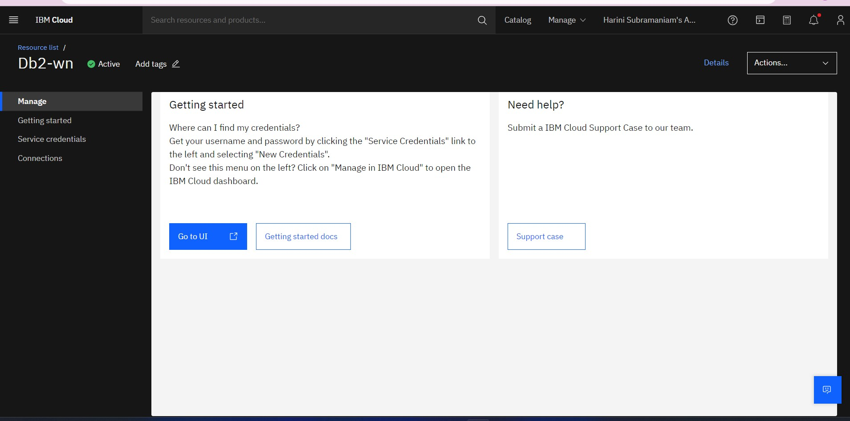

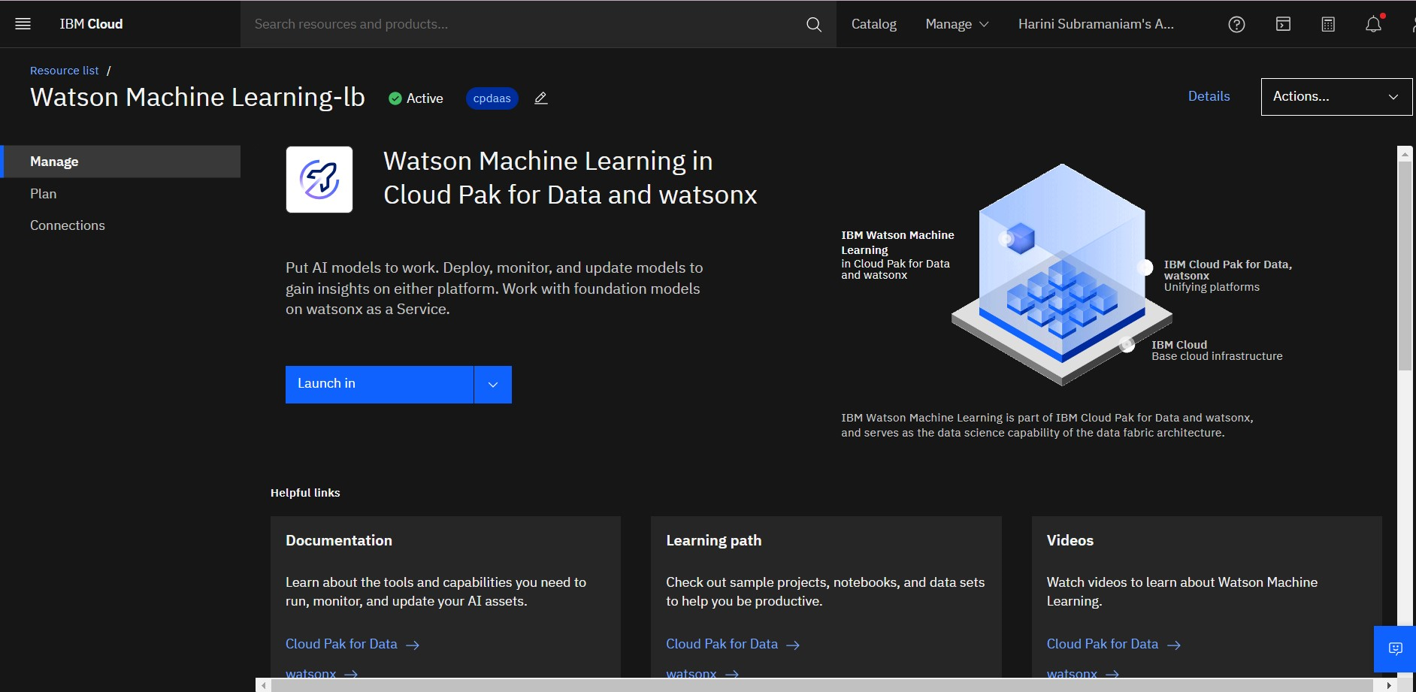

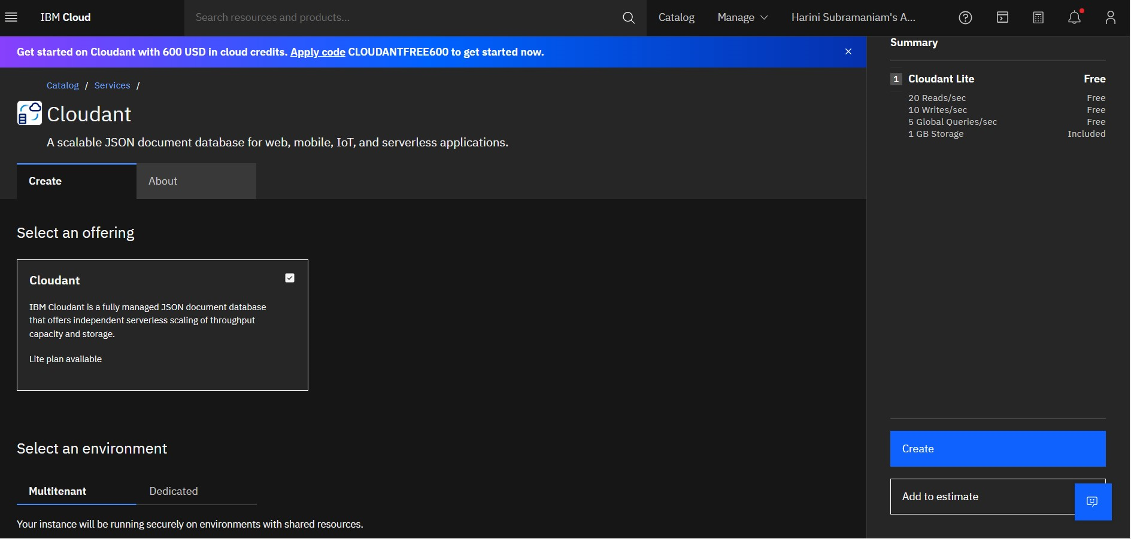

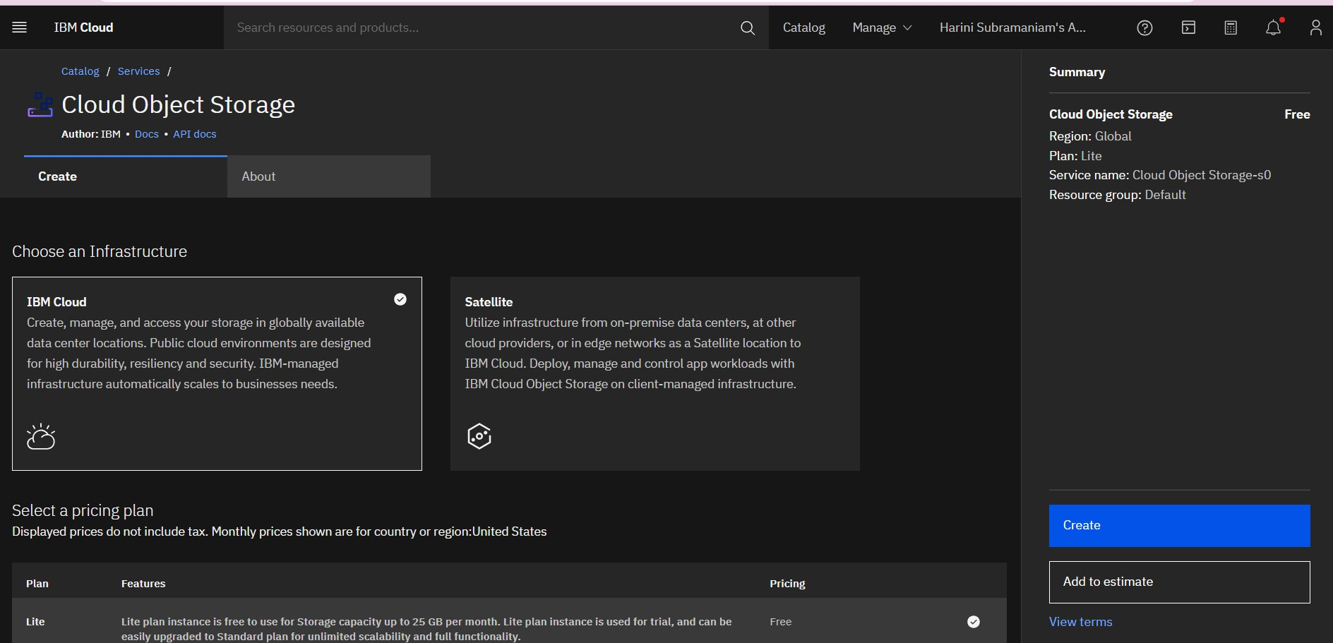

**5.Data Exploration and Analysis:**

Data exploration and analysis in the context of data security and privacy in big data analysis involves examining and understanding datasets while adhering to stringent security and privacy measures.

Exploring Dataset :

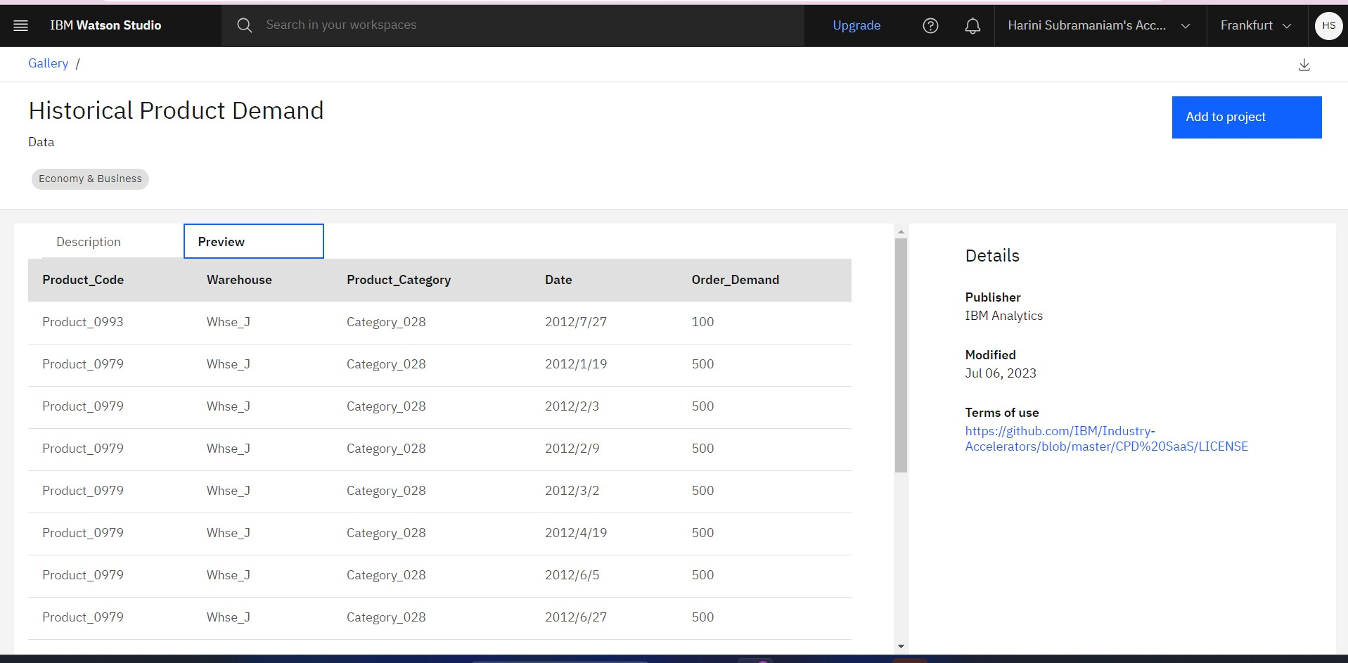

Data Assets of the Historical product Demand:

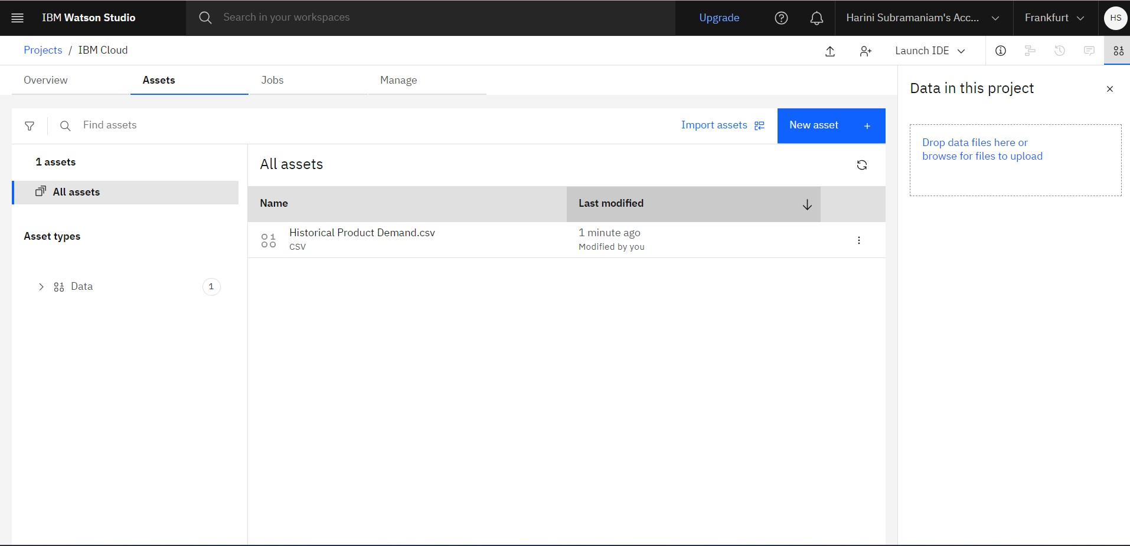

Creating New notebook:

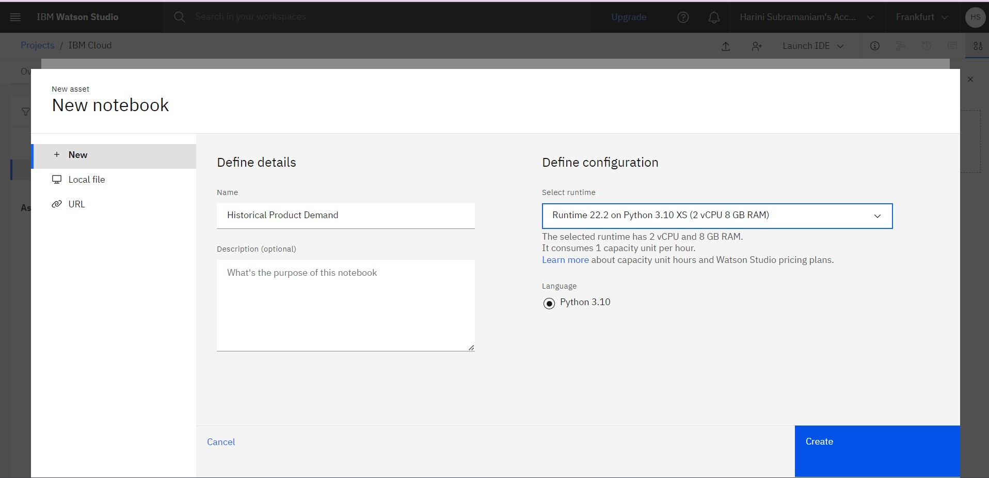

**5.1 Query to Explore the Dataset:**

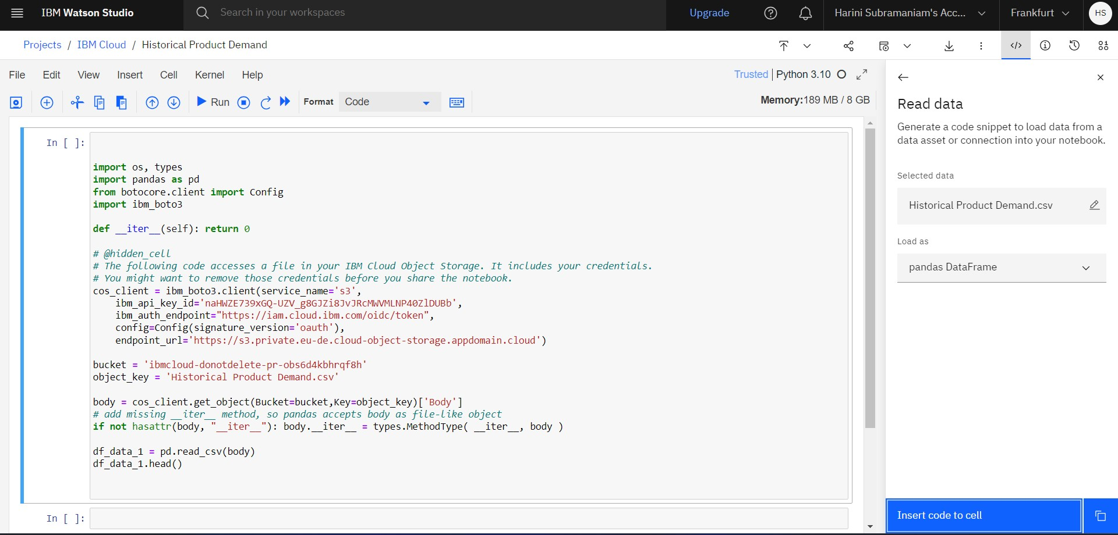

**6.Data Cleaning and Transformation:**

Data cleaning and Transformation contribute to the overall data quality, ensuring that the insights derived from analysis are accurate and actionable. These processes are crucial in various domains, from business intelligence to machine learning, where the reliability of results depends on the integrity of the underlying data**.**

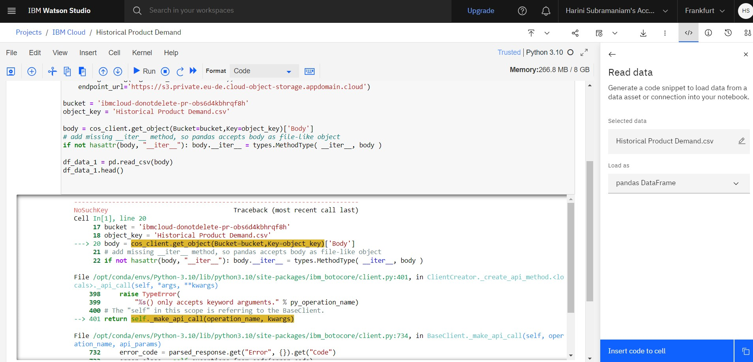

**7.Conclusion:**

The successful exploration and analysis of data in the realm of data security and privacy require a holistic approach that integrates legal compliance, ethical considerations, and robust technical measures. By following best practices and staying informed about changes in regulations, organizations can responsibly derive valuable insights from data while upholding privacy standards**.**